13.21: a) Dividing Eq. (13.17) by ,
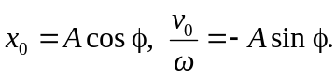
Squaring and adding,
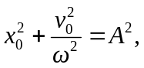
which is the same as Eq. (13.19). b) At time 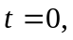 Eq. (13.21) becomes
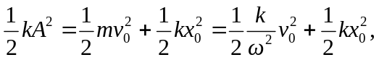
where 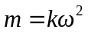 (Eq. (13.10)) has been used. Dividing by 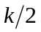 gives Eq. (13.19).

